Email signature gallery template
Pick any signature in this template and easily customize it with your own logo, photo, website & social profiles to create a professional looking email signature. Follow the instructions to use the template:
Step 1: Hover over the signature and click to select all the elements in the signature.
Step 2: Select Copy (Ctrl + C).
Step 3: Open an Outlook email message and Paste (Ctrl +V) the signature in the email body.
Step 4: Watch this video to learn how to customize your signature with your photo/logo, website.

Signature 1

 | Lorenzo Corbitt (He/him/his)  Vice-President at Contoso, Ltd.  Phone 462-835-2759 Mobile 462-423-4718  Web www.contoso.com Email lorenzo@contoso.com  2345 South Main Street, Sacramento, CA 98157  

Signature 3

Iva Mooney  (She,her,hers)  President & CEO | 
6789 Bellow Road • Sacramento, CA 94403
Consolidated Messenger

653-681-4267
653-792-3529
iva@consolidatedmessenger.com
www.consolidatedmessenger.com

Signature 5

   | Francis Steel (He/His/Him)  Executive President at Contoso, Ltd.  Email: francis@contoso.com  Phone: 462-835-2759 | Mobile: 462-423-4718  2345 Silverado Avenue, Baton Rouge, LA 00802  www.contoso.com

Signature 2

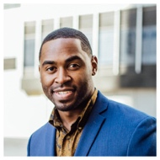 | Harlan Donato  President at Contoso, Ltd.  Phone: 462-835-2759  Mobile: 462-423-4718  Email: harlan@contoso.com  5678 Washington Street  Houston, TX 88915  www.contoso.com  

Signature 4
Dixie Cameron (She/her/hers)  CEO at Alpine Ski House  Phone: 462-835-2759  Email: dixie@alpineskihouse.com  789 Happy St, Nashville, TN 32217 www.alpineskihouse.com   | 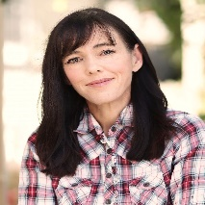

Signature 6

 | Account Executive  HOWARD DRIGGERS  359-952-9762  howard@contoso.com | 4567 William St.  Ypsilanti, MI 48897  

Signature 7

Kind Regards,
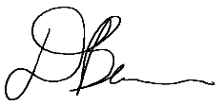

Dianna Burns, President
Fabrikam Residences

Phone: 462-835-2759

Mobile: 462-423-4718
Web: www.fabrikamresidences.com
Email: dianna@fabrikamresidences.com
6789 Liberty Street, Albany, NY 12303



Signature 9

Robert Fannin  They/them/theirs  Marketing Specialist | 
Email: robert@bestforyouorganics.com
Mobile: 562-325-6651
Best For You Organics Company
3456 Wilson, Milwaukee, WI 50035

 |  |  |  | 

Signature 11

 | IRVIN MUSSELMAN  Digital Marketing Manager  

Mobile: 625-562.8953 Email: irvin@contoso.com

Web: www.contoso.com Address: 2345 Mullen Street, Boston, MA 02009

Signature 13

   | Federico Bernhardt  Photographer  Phone: 824-425-5626  Email: fedrico@fabrikam.com  Fabrikam, Inc.  3456 Howard Lane | Ocean City, NJ 02826

Signature 8

Roland Lundgren
(They/Them/Theirs)
Director

4567 South Main Street, Suite 100
Saint Louis, MO 88904

345-213-5234 | 942-453-5727 (cell)
roland@adatum.com | www.adatum.com



Signature 10

 | CONTENT MANAGER  JEWELL PATEL
453-267-5636
jewell@bellowscollege.com
2345 Main Street, Suite 336
Lansing, Michigan 99897
bellowscollege.com



Signature 12

 | JANE HESS  Marketing Director | Phone: 385-462-0324  jane@adventure.com  adventure-works.com  3456 North Seymore  Los Angeles, CA 90000  

Signature 14

Kathleen Fields  Writer  kathleen@alpineskihouse.com  453-325-2567  www.alpineskihouse.com | 

Alpine Ski House • 4567 Valley • Los Angeles CA 90000

Signature Template 15

Morgan Nemeth  Sales & Marketing Director  morgan@contososuites.com  Phone: 386-425-6346  www.contososuites.com | 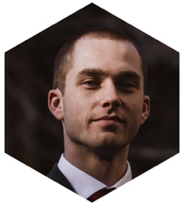


Signature 17

  MARI CARVER  Head Designer | MOBILE:  EMAIL:  WEB:  ADDRESS: | 542-426-0580  mari@fabrikam.com  fabrikam.com  6789 King Hill Road  Houston TX 45678  

“Digital design is like painting, except the paint never dries.”

Signature 19

Dora Caldwell

Systems Administrator

Fabrikam Residences
Phone: 835-922-2567 Mobile: 835-723-5372
3456 Walter Street, New York NY 10000
Web: www.fabrikamresidences.com
Email: dora@fabrikamresidences.com




Signature 16

Rachel Church
Operations Manager

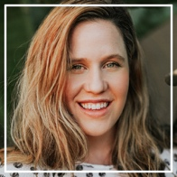

Phone: 536-345-6736
Email: rachel@adatum.com
Web: www.adatum.com

Adatum Corporation
3456 Argo Drive | Los Angeles, CA 93000



Signature 18

Christian Saul  (He/his/him)  Marketing Director | 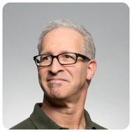
Phone: 764-463-6368  Mobile: 764-454-5676  christian@bellowscollege.com | Bellows College  4567 South University Drive  San Francisco, CA 94000
 | www.bellowscollege.com

Signature 20



JENNIE TERRY Project Manager

635-268-9270 |  jennie@adatum.com |  adutum.com
3456 Railroad Avenue, Staten Island, NY 10000

